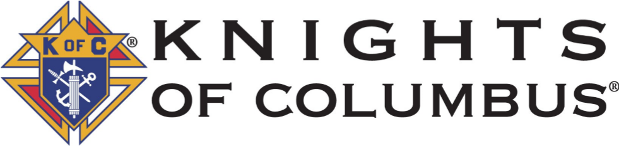
Msgr. Eugene F. Marshall
Council 103
P.O. Box 618
Pittsfield, MA 01201

Dear Applicant,

Thank you for your interest in applying for the Council 103 Scholarship. The application is used for both the postsecondary education and Career & Technical Education Programs. Each award is $500.00 and is made directly to the recipient upon certification of completion of your first semester or grading period.

Students enrolled in postsecondary education must receive an overall GPA 2.0 for their first semester. Students enrolled in a career or technical education program can submit documentation indicating successful completion of the first semester in the event the program does not grade on a standard 4.00 system.

Completed applications or questions may be submitted to the Committee by emailing them directly to council1031@gmail.com or by mailing them to the Council at the above address.

Sincerely,

Robert Bouquet

Robert Bouquet, Chairman
Council 103 Scholarship Committee

Msgr. Eugene F. Marshall
Council 103

Postsecondary Education Scholarship Application for 2024

All information is held in strict confidence

Applicant’s Name - _____________________________________________________

Address - _____________________________________________________________

City - _________________ State - ________ Zip Code - _______________

Email - _______________________________________________________________

High School currently attending -___________________________________________

If you completed SAT, please include scores below:

SAT Math - _______ SAT Reading - ________ Writing & Language- _________

If you completed ACT, please include scores below:

ACT English - ______ ACT Math - ___________ ACT Reading - _____________

ACT Science - _______ ACT Writing - ___________

Number in Family - _____ Currently attending Postsecondary Education - _________

Yearly family income - $_______________________
If There are extenuating circumstances, please provide additional information.
____________________________________________________________________________________________________________________________________________________________________________________________________________________________________________________________________________________________________________________________________________________________________________________________________________________________________

Are you the child or grandchild of a member of Council 103? Yes - _____ No - _____

Name of Council Member - ________________________________________________

Name of Parish - ________________________________________________________

Please describe your involvement with the Parish Community.
____________________________________________________________________________________________________________________________________________________________________________________________________________________________________________________________________________________________________________________________________________________________________________________________________________________________________

Signature of Pastor/Administrator - __________________________________________

